Thank you
to the 120 members and guests of
Presbytery of Wabash Valley
who gave of their time to attend the
November 18 Assembly

On Tuesday, Nov. 18th, more than 120 people gathered at Geneva Center an hour earlier than usual to worship and study scripture, share a meal, elect and install presbytery leadership, learn, and make some major decisions to further our work together. Highlights and headlines of Presbytery Assembly:
- Approved Geneva Center be spun-off into its own not-for-profit corporation and that Council form a Geneva Center Transition Team to be named by January 1, 2015, to form its own non-profit organization and corporate structure to govern and administer all operational aspects of the ministry and mission of Geneva Center.
- Led by outgoing Council Moderator Kevin Bowers, Bethany, Lafayette) installed Ruling Elder Jill Kitowski (La Porte) as Assembly Moderator, Teaching Elder Jeff Cover (Central, Lafayette) as Council Moderator, and elected and installed Teaching Elder David Smook (Honorably Retired) as Vice Moderator.
- Examined and approved Candidate Will Roberts for ordination to be called and installed pastor of the Pierceton congregation.
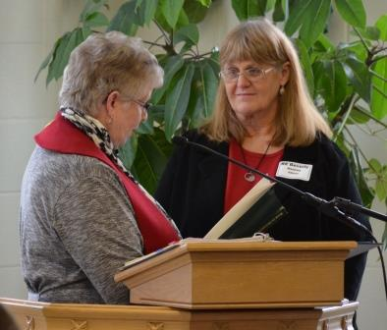
Jill Kitowski & Beverly Harkey
- Commissioned ruling elder Beverly Harkey (Kendallville) to serve as co-pastor with CRE Martha Flora with Albion congregation.
- Approved policy for COM's appointment of trained ruling elders as temporary moderators of session.
- Approved the closing of the Thorntown Presbyterian Church of year-end, with appropriate celebrations of its ministry and gave authority of AC to negotiate sale of the property for ongoing community service and ministry, subject to Council approval.
- Elected nominees to 28 leadership positions for presbytery work.
- Voted by paper ballot (58 yes, 34 no, 2 abstain) to refer Joshua Journey Team 2 recommendations of structure, Transitional Presbyter, and an implementation team to a new Team of Five to be named by Presbytery Moderator, Council Moderator and Vice Moderator, to report its recommendations to the February 24, 2015 Assembly. Discussion and presbytery financial reports showing ongoing deficit made clear that reorganizing presbytery work is essential, but current proposal was problematic.
- Dissolved the administrative commission charged to walk with the Plymouth congregation, and thanked the AC for its work.
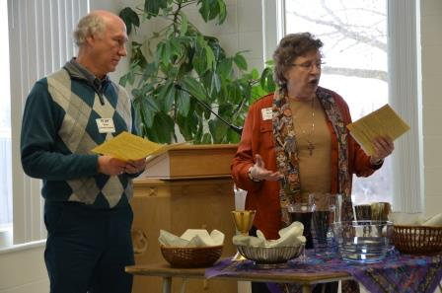
- Celebrated the liturgy and Sacrament of Holy Communion led by Teaching Elder Sue Babovec (Peabody chaplain) and sermon by Jeff Cover on Numbers 13: "There be giants out there!"
- Welcomed Synod Transitional Executive Sara Dingman and recognized Doug Hoffman as a certified Christian Educator.
- Contributed $665 for the PC(USA) Christmas Joy offering for financial assistance to current and former church workers and their families and students attending Presbyterian-related racial ethnic colleges and schools.
- Approved continued allocation of costs for presbytery work at $27.95 per active member. Therefore total per capita for 2015: Synod $3.81; PWV 27.95; OGA $7.07 = $38.83 per active congregational member.
- Shared joys, concerns and prayers before adjourning at 3:10 pm.

